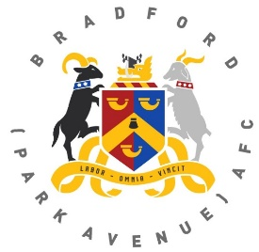
Bradford (Park Avenue) AFC
Goal Sponsorship Application Form

Supporters can take part in the goal sponsorship scheme by sponsoring the players for each goal scored, every hat trick and every clean sheet.
You can take part at any rate of your choosing. Goal sponsorship money will be called in three times during the season, although you can pay money towards your sponsorship running total or check the figure of your running total any time at the Supporter’s Desk in the clubhouse.
This season the calls will be made on.
1st October 2020 1st February 2021 1st May 2021

Full Name ………………………………………………………………………
Telephone No …………………...........
Email Address ………………………………………………………………………
I would like to sponsor £………………………….per goal scored.
I would like to sponsor £………………………….per clean sheet kept.
I would like to sponsor £………………………….per hat trick scored.
If you would like to make an upfront payment for your sponsorship please make a payment to the following:
I enclose a cheque for £ ……………made payable to ‘BPA Development Fund’
OR
I have paid by bank transfer to the following account:
BPA Development Fund Sort Code 05-06-81 Account Number 33569976

Signed ………………………………………… Date …………………….
Please send this completed form to:
BPA Development Fund, Horsfall Stadium, Cemetery Road, Bradford BD6 2NG,
Or email it to: bpadevelopmentfund@hotmail.com

