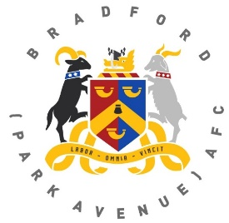
Bradford (Park Avenue) AFC
Pitch Square Sponsorship Application Form

Supporters can claim part of the pitch as their own by sponsoring a pitch square in the pitch square sponsorship scheme for the upcoming 2021-22 season.

Pitch square sponsorship for the season is priced at £10 per pitch square.

As an added incentive for this season once all squares are sold, we will be holding a monthly prize draw with the winning pitch square winning £25.

Full Name ………………………………………………………………………
Telephone No …………………...........
Email Address ………………………………………………………………………
Square No …………………...........
I enclose a cheque for £ ……………made payable to ‘BPA Development Fund’
OR
I have paid by bank transfer to the following account:
BPA Development Fund Sort Code 05-06-81 Account Number 33569976

Signed ………………………………………… Date …………………….
Please send this completed form to:
BPA Development Fund, Horsfall Stadium, Cemetery Road, Bradford BD6 2NG,
Or email it to: bpadevelopmentfund@hotmail.com

