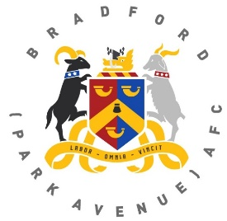
Bradford (Park Avenue) AFC
Player Sponsorship Application Form

Supporters can take part in the player sponsorship scheme by sponsoring your favourite player home or away for the upcoming 2022-23 season.

Player sponsors will be credited in the match day programme and online.

New player sponsorship for the season is priced at £70 for either Home or Away.

Alternatively if you wish to renew a sponsorship from the 2021-22 season this is priced at £60 for either Home or Away

Full Name ………………………………………………………………………
Telephone No …………………...........
Email Address ………………………………………………………………………
Player Sponsored …………………………………………………………………..
Home Or Away ……………………….
In the normal course of the season, players may be transferred or sent out on loan to other clubs. Should this happen to a player that is subject of a player sponsorship deal then the sponsor will be offered the chance of transferring their sponsorship to another unsponsored player in the squad.
I enclose a cheque for £ ……………made payable to ‘BPA Development Fund’
OR
I have paid by bank transfer to the following account:
BPA Development Fund Sort Code 05-06-81 Account Number 33569976

Signed ………………………………………… Date …………………….
Please send this completed form to:
BPA Development Fund, Horsfall Stadium, Cemetery Road, Bradford BD6 2NG,
Or email it to: bpadevelopmentfund@hotmail.com

